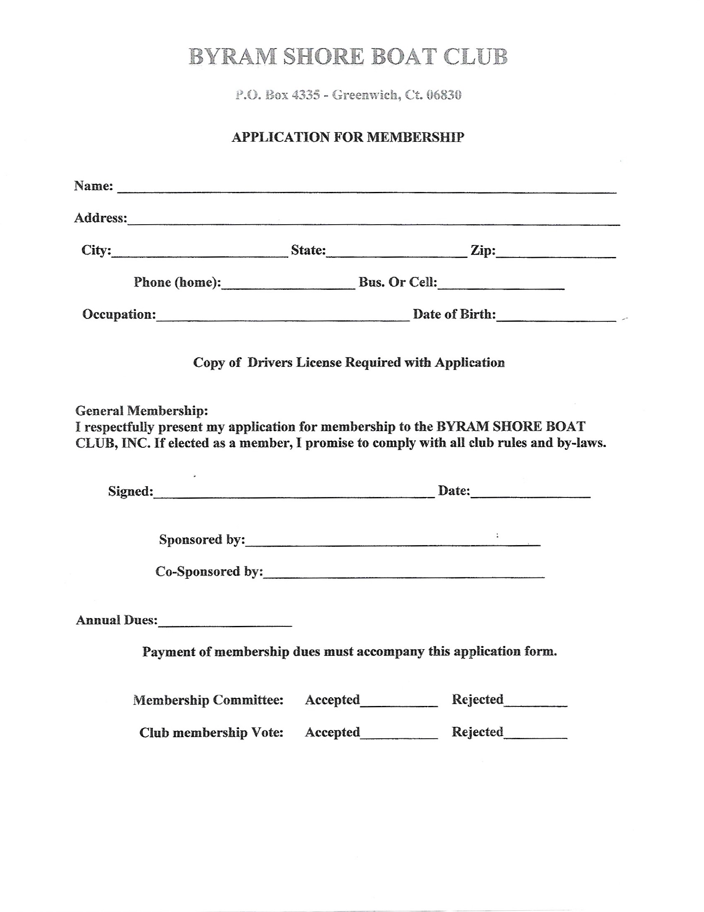

email address:

$150 New Member Application Fee $95